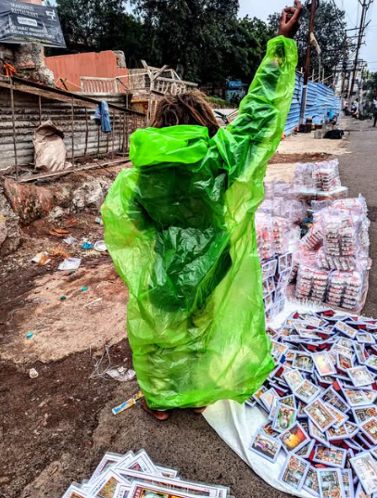
It is a Sunday.

A sunny one at that.

Some are spending their time fixing their central air conditioners, others, changing the husk in their cooler.

Many, who have neither, do both.

Summer is coming.

It is a Sunday.

A rainy one at that.

Some scroll through their phones looking for sweaters, planning for the fall look.

Others with slight reluctance, have given in to the children's demands.

The food delivery app is dusted off, and pizza is ordered to set mood before neighbours and their kids come.

Many, on their way, deliver for both, happy tonight, they get a raincoat.

Winter is coming.

It is a Sunday.

A chilly one at that.

The week has been laboured away. On the chair, at the desk, in the mine or by the road.

And yet, the some, the others, and the most, all gather at the townsquare.

At the center, a man holds a board.
"I have seen god" he proclaims.

But that's not why the crowd's there.

They're here for his robes.

The robe changes colour.
Saffron, green, white blue and black-
And then shades seen by no other.

So does his beard, change shape.
Some days you see his face.
Some days you wonder,
Does he ever shave?

Now, the some, the others, the most,
Labour through Sundays, to visit his post.
The harsher the Sunday, the higher the toast,
The more they love the beard and robe.

A child walks in. Unphased by the robes.
Somehow, in the shimmer of her eyes,
The world itself flows.

The beard is but a bush, and clean cheeks, just rough roads.

Unimpressed, by the some, the others, the most,

And especially - the man with the board.

Before she faded back into the crowd,
She turned around, held a chalk,
And wrote in bold-

It is a Sunday.

A figrid, scorching and flooded one at that.

When shall spring come?

